Chapter 19, Solution 31.

We get 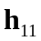 and 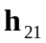 by considering the circuit in Fig. (a).
2 
4 I₁
1 
1 
I₁
V₃
V₄
(a)
+
V₁
−
2 
I₂
At node 1,
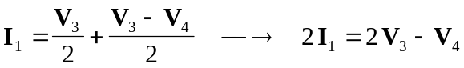 (1)

At node 2,
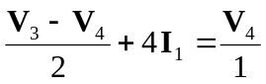
(2)

Adding (1) and (2),
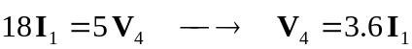
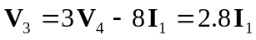
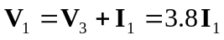
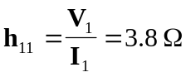

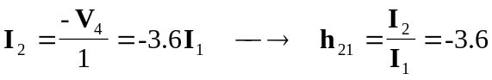

To get 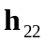 and 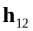, refer to the circuit in Fig. (b). The dependent current source can be replaced by an open circuit since 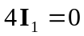.
2 
4 I₁ = 0
1 
1 
(b)
+
V₁
−
2 
I₂
V₂
+
−
I₁

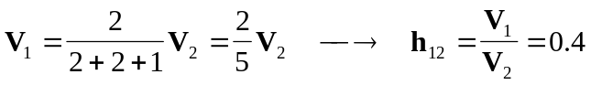

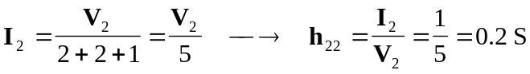

Thus,
